|  |  |  |
| --- | --- | --- |
| **INPUT CHARACTER** | **STACK** | **POSTFIX EXPRESSION** |
| A | Empty | A |
| * | * | A |
| B | * | A B |
| – | – | A B * |
| ( | – ( | A B * |
| C | – ( | A B * C |
| + | – ( + | A B * C |
| D | – ( + | A B * C D |
| ) | – | A B * C D + |
| + | + | A B * C D + – |
| E | + | A B * C D + – E |
| End of Input | Empty | A B * C D + – E + |

1. Write an algorithm to convert an infix expression to postfix and infix to prefix

**POSTFIX EXPRESSION :- A B * C D + – E +**

|  |  |  |
| --- | --- | --- |
| **INPUT CHARACTER** | **STACK** | **EXPRESSION** |
| F |  | F |
| ^ | ^ | F |
| ) | ^) | FE |
| E | ^) | FE |
| – | ^)- | FE |
| D | ^)- | FED |
| ( | ^)- | FED- |
| – | – | FED-^ |
| C | – | FED-^C |
| + | + | FED-^C- |
| ) | +) | FED-^C- |
| B | +) | FED-^C-B |
| + | +)+ | FED-^C-B |
| A | +)+ | FED-^C-BA |
| ( | + | FED-^C-BA+ |
|  |  | FED-^C-BA++ |

**PREFIX EXPRESSION : ++AB-C^-DEF**

2. Write an algorithm to evaluate a postfix and a prefix expression

**A. Prefix**

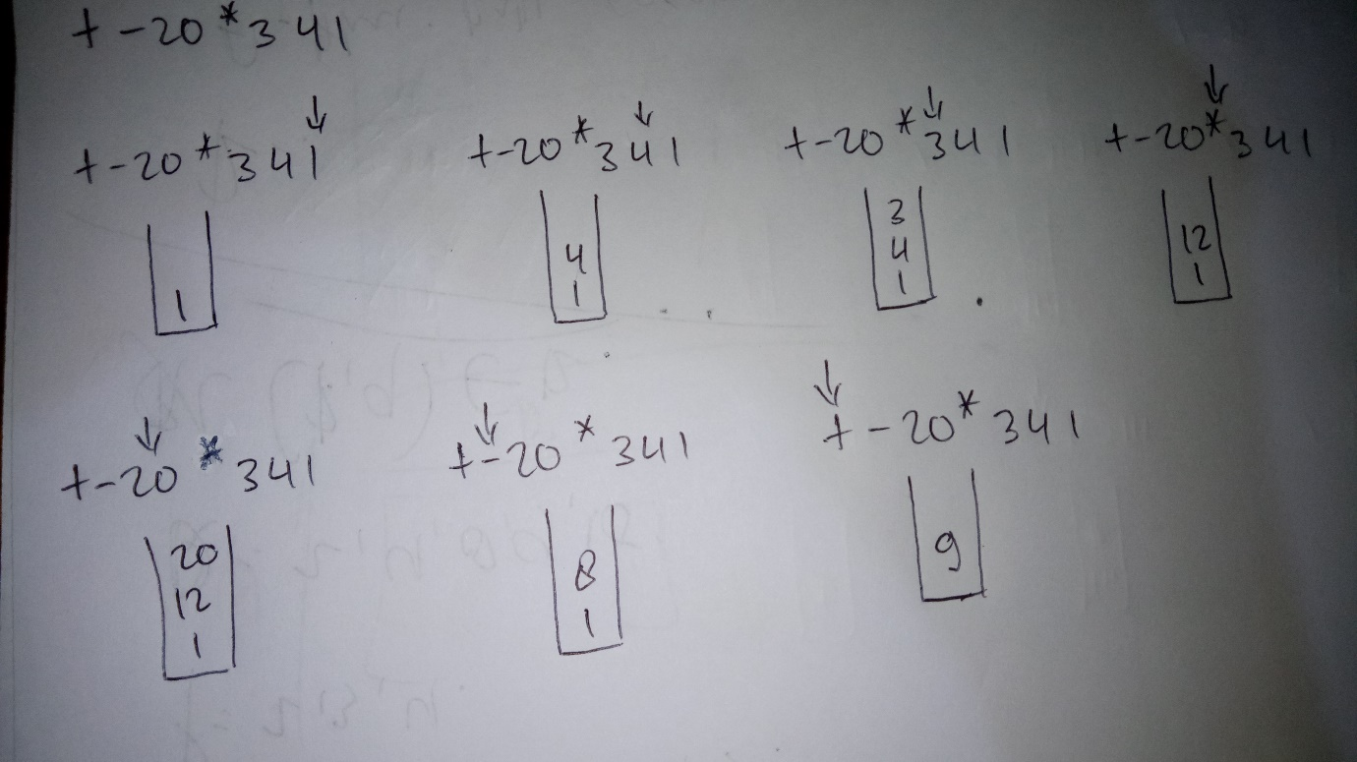

**B. Postfix**

